**LAB 9 report**

**JWT TOKEN AUTHENTICATION**

**INTRODUCTION:**

JWT means JsonWebTOKEN, this is used to securely transfer data between two bodies, it is used to block unauthorized users from accessing a particular website or data and only allowing authorized users to access it.

In this tutorial we are going to see how we create a JWT authentication for a web app.

**Pre Requisites:**

* For this tutorial we need node .js
* A code editor(we used vs code)

**Implementation:**

* First we have to create a directory in which we have to save and run the app, remember the path for it and now install the latest version of node.js into your local machine.
* Now,set the path to your project location,first we need to create a package.json file which contains the outlook of the project and basic details.
* For this we need run the command “**npm init**”

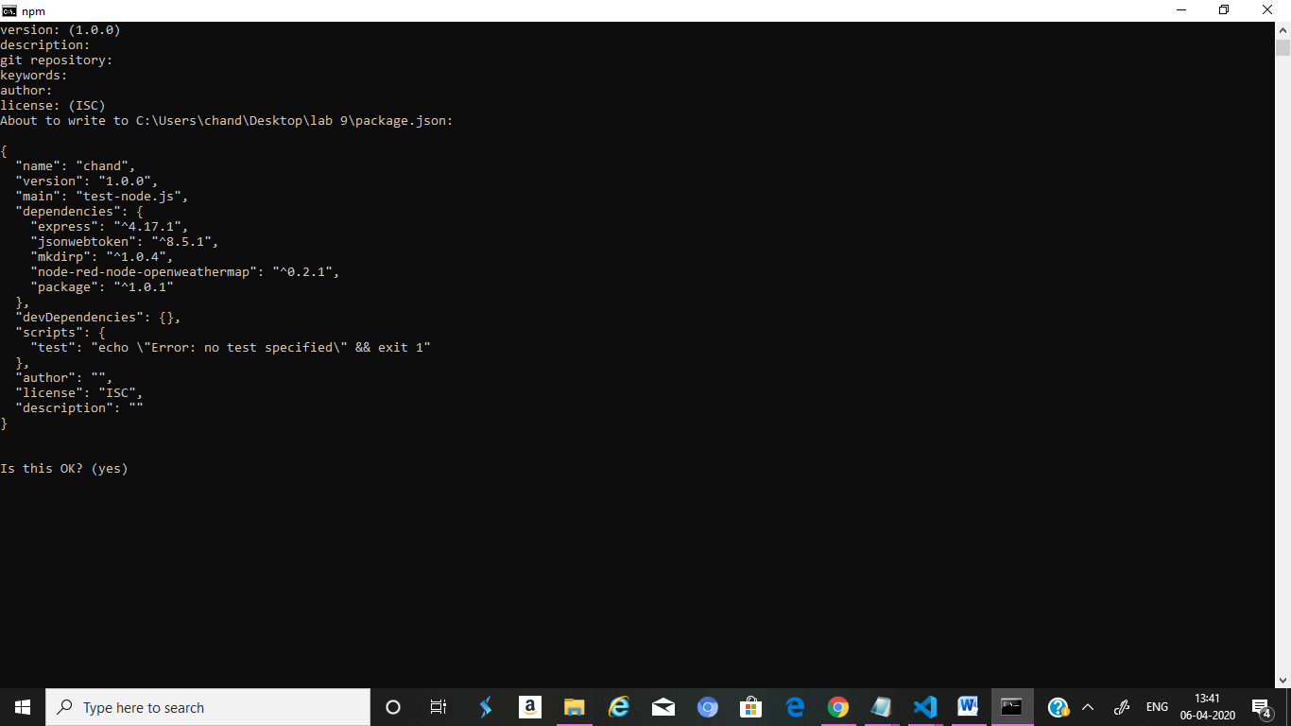

**Package.json creation**

* The system itself generates values for now you can proceed with the default values,after creating it save it as package.json in your project file.
* Now we have install express into our project to proceed with the authentication,for that use the command

**“ npm install express --save”**

* Now every package are installed into your project and now we have to create our index file with get command and secret command for accessing the web app, after creating the index file,save it in your project file and to run this web app,we should write the command

**“node index.js”**

* When we write the index code,we should assign a port to it,so when the machine runs it,it will be displayed in that port of the default browser.
* For now,we have assigned port 3000 to our app and it will run in port 3000 when we run it.

**C:\Users\chand\Desktop\pallavi\Capture.JPG**

**App running in local host**

* Next we have to create a pem file with a private key so that when unauthorized user uses it ,it won’t give access to them.
* Before creating pem file we have install jwt package into our project,for that run the following command.

**“npm install –save jsonwebtoken”**

* After this you can create the pem file and add the private key to it and save it in your project folder file.
* Now when you give the url in local host 3000 portal as get it will display what information you have given to display and when you access it as secret it will display concerned information, when you write jwt it will display a key of authorization.

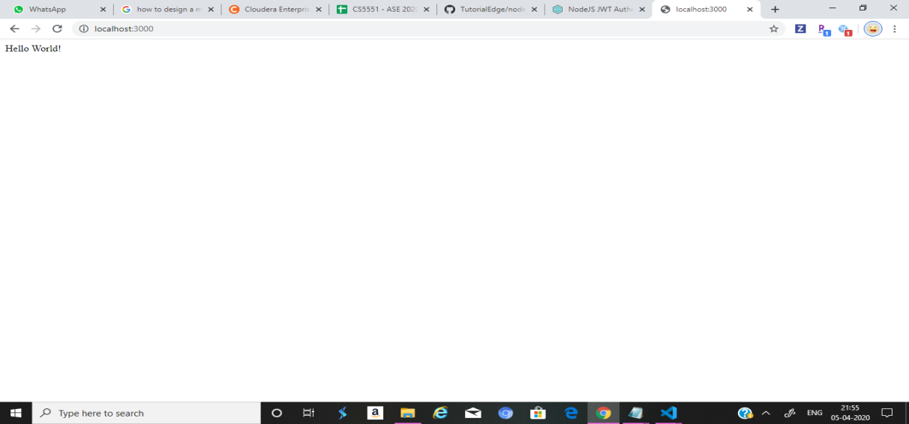

**Basic app running in local host**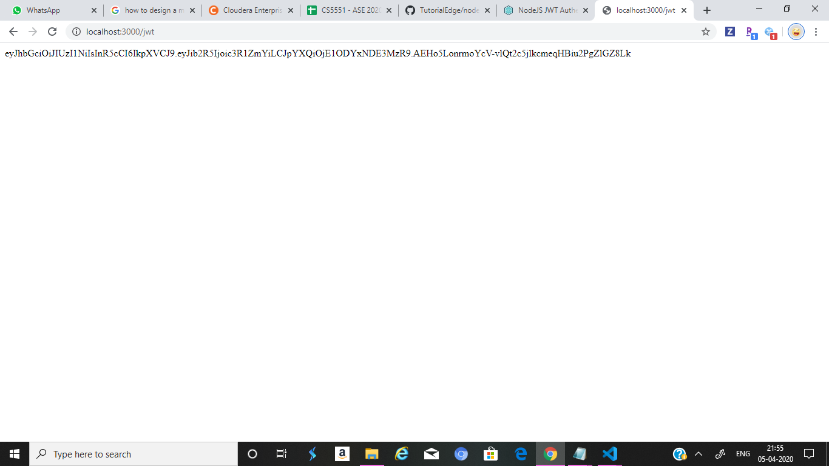

**When you run the app with JWT url**

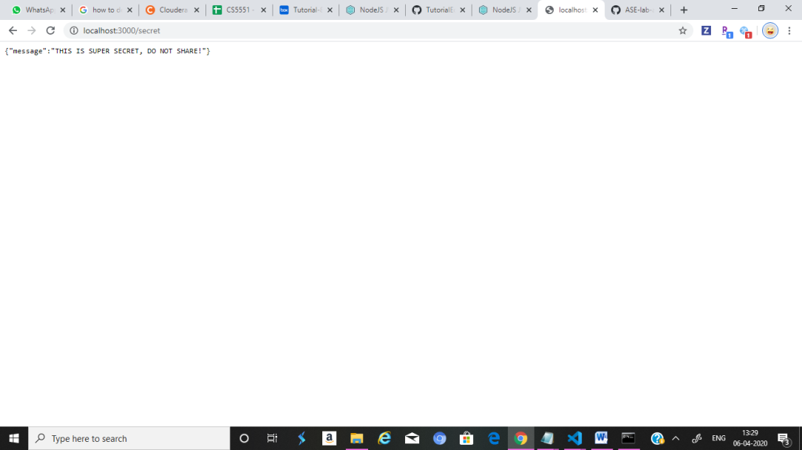

**When authorized user access the app**

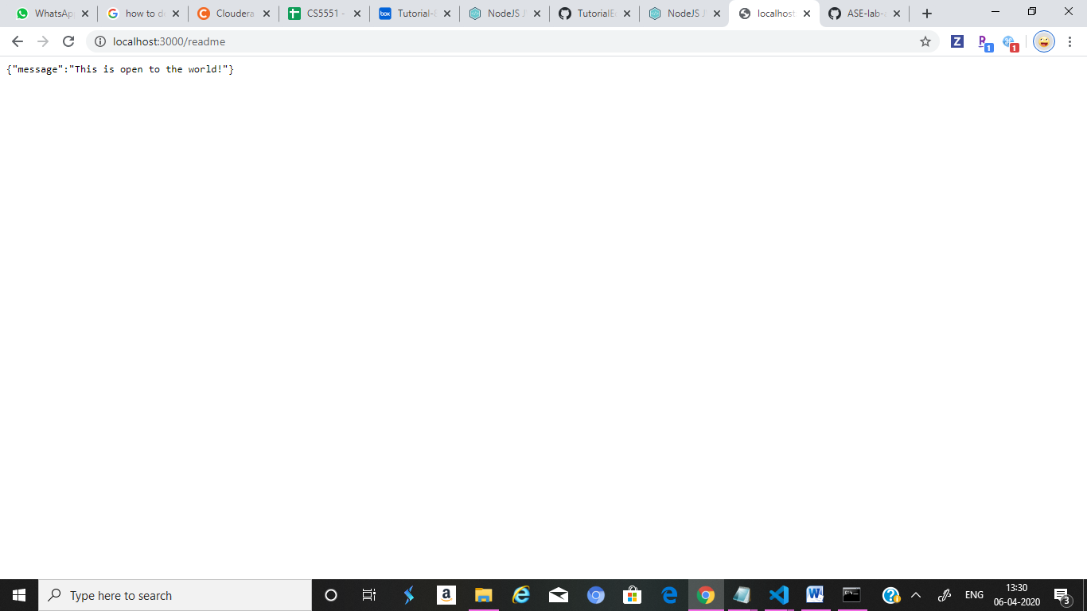

**Before giving jwt authentication**

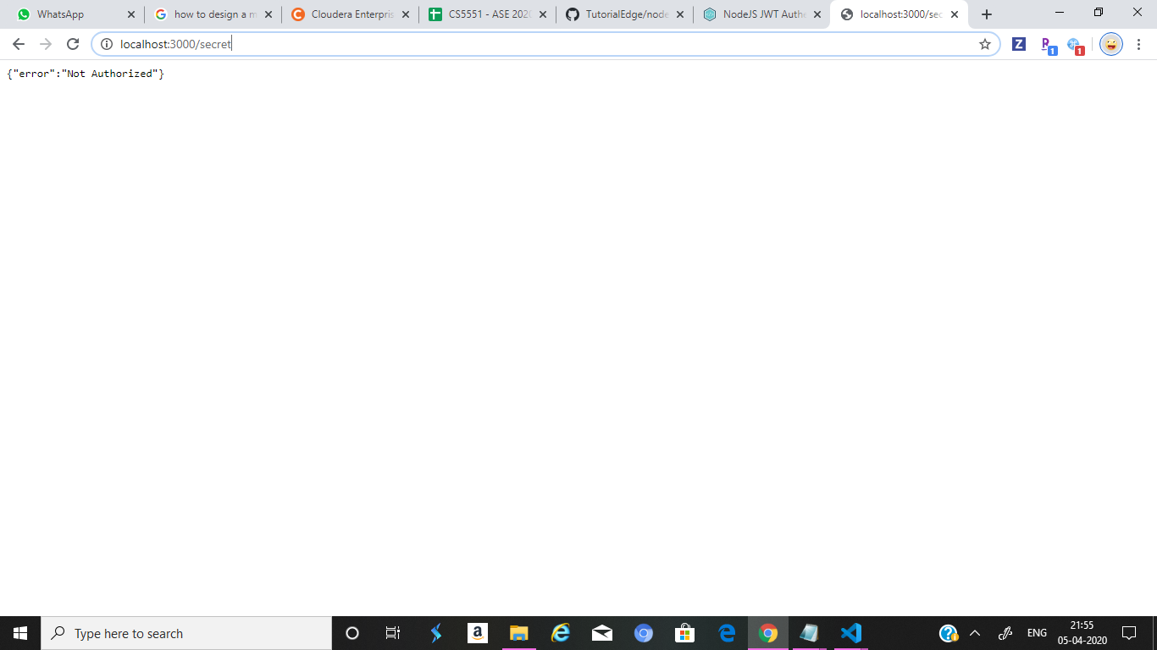

**After authentication of JWT**

* This is how you do the JWT authentication.

**Limitations:**

* When creating the pem file, the key should be correct because the authorization depends on this key so we have to give the same key as in the authorization certificate.

**Conclusion:**

* in this tutorial we have learned how to give JWT authorization to our web app and what is JWT and what is giving authorization.
* In this lab we learnt how to use express to give JWT authorization.

**References:**

<https://tutorialedge.net/nodejs/nodejs-jwt-authentication-tutorial/>

**Team members:**

Karishma yallanki class:id-29

Tejaswi Guturu class:id-16